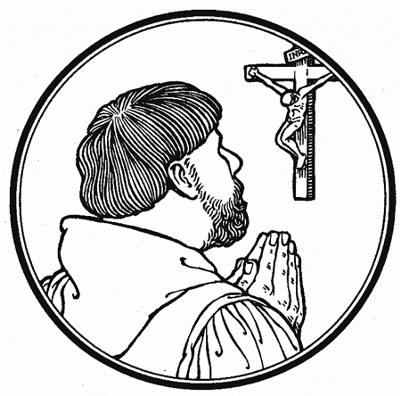
The Fifth Sunday after Easter
Sunday, May 5, 2024
The Lesson of Christian Prayer:
“He is Risen to Carry the Prayers of Believers to God”

Hymn of Invocation: “Now Thank We All Our God” (rise on stz. 3) LSB 895
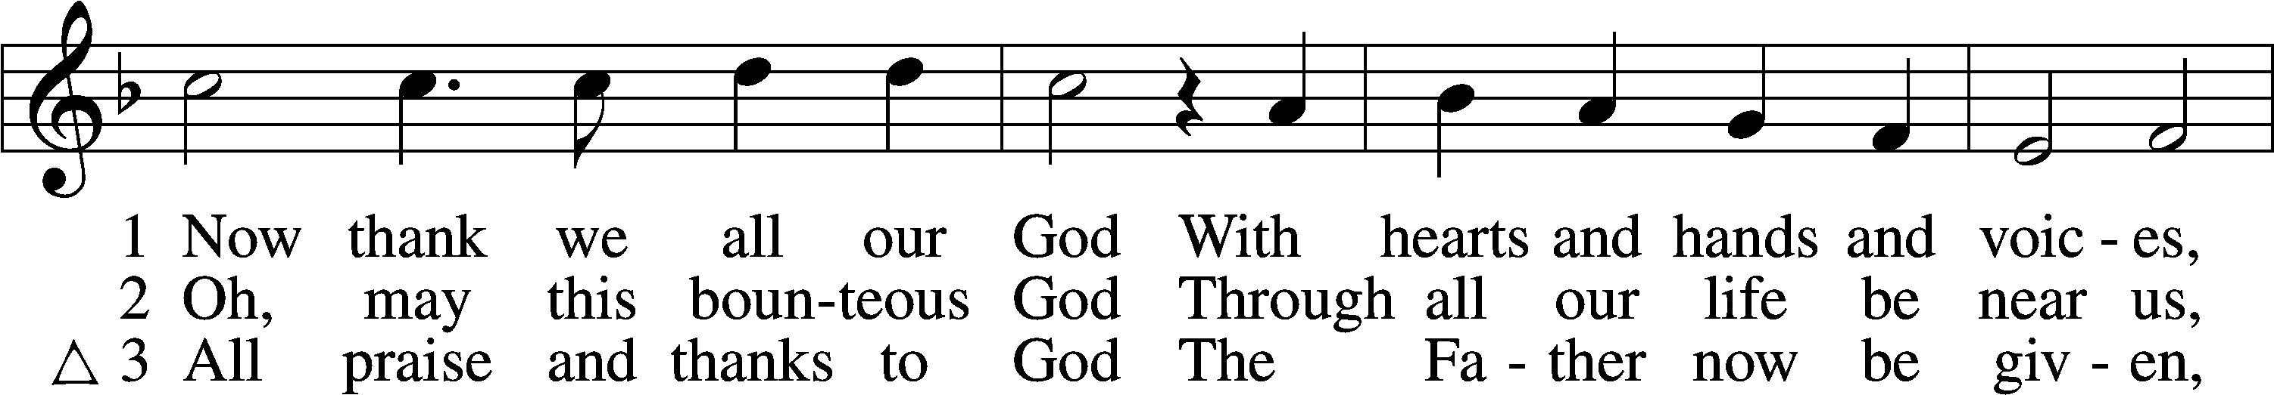
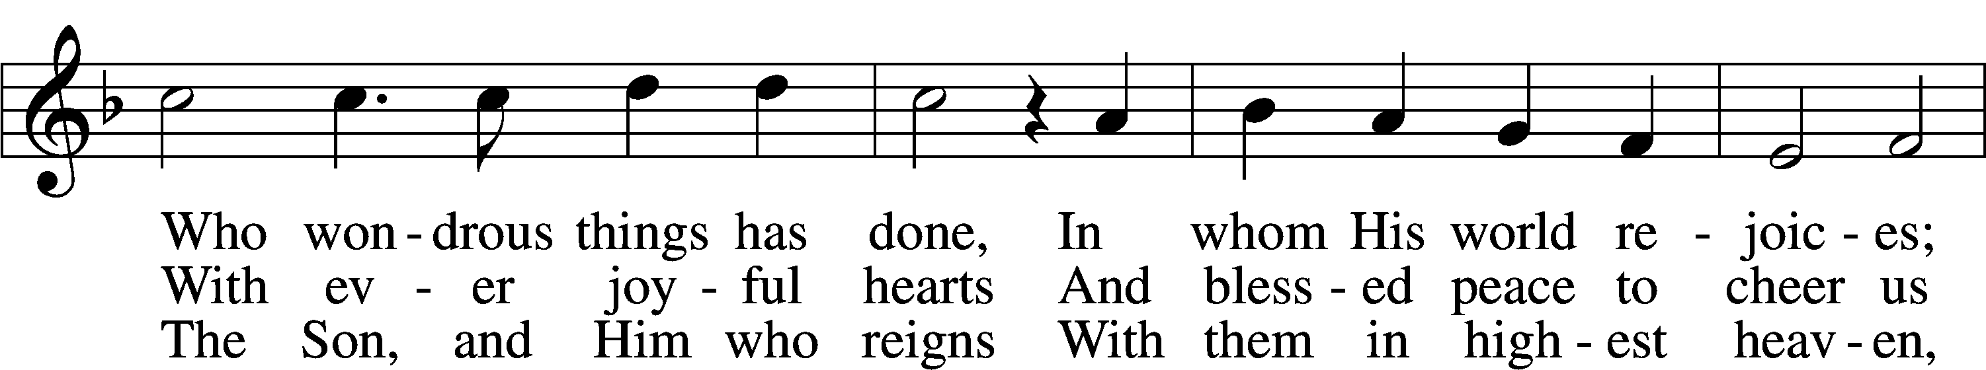
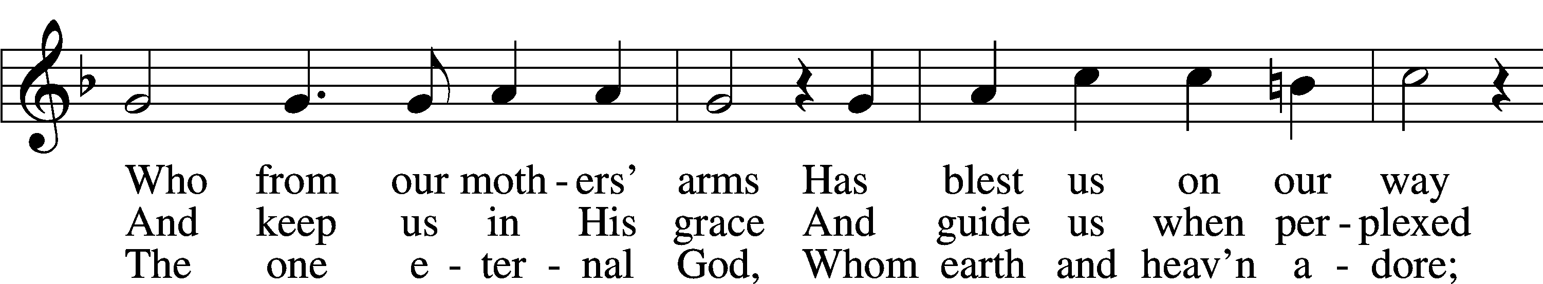
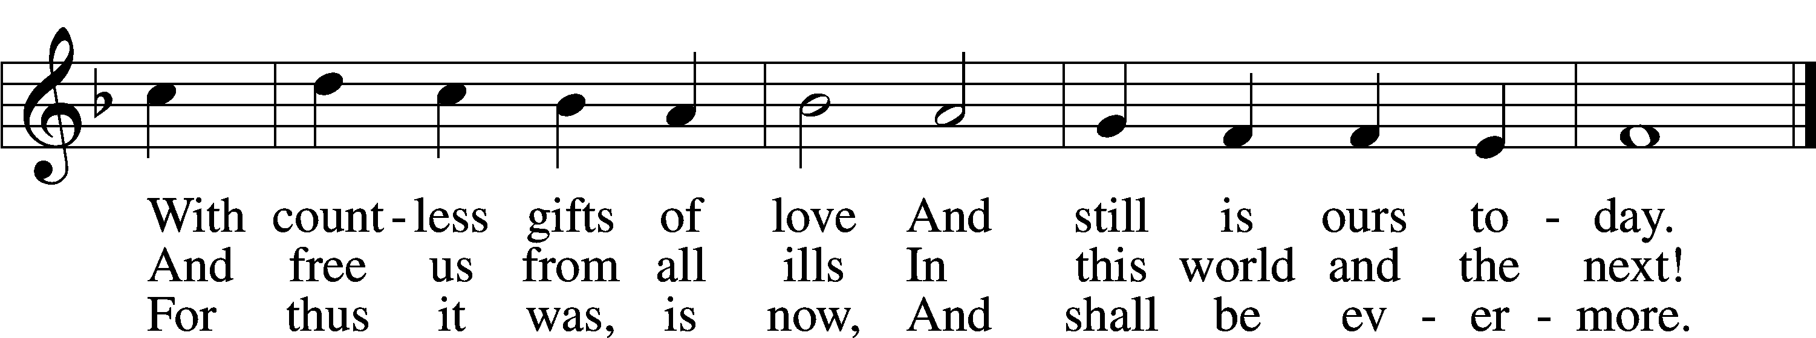
Text: Martin Rinckart, 1586–1649; tr. Catherine Winkworth, 1827–78, alt.
Tune: Johann Crüger, 1598–1662
Text and tune: Public domain

Invocation, Confession of Sins and Absolution LSB 184
The sign of the cross may be made by all in remembrance of their Baptism.

P In the name of the Father and of the T Son and of the Holy Spirit.
C Amen.
P Beloved in the Lord! Let us draw near with a true heart and confess our sins unto God our Father, beseeching Him in the name of our Lord Jesus Christ to grant us forgiveness.
P Our help is in the name of the Lord,
C who made heaven and earth.
P I said, I will confess my transgressions unto the Lord,
C and You forgave the iniquity of my sin.

Silence for reflection on God’s Word and for self-examination.

P O almighty God, merciful Father,
C I, a poor, miserable sinner, confess unto You all my sins and iniquities with which I have ever offended You and justly deserved Your temporal and eternal punishment. But I am heartily sorry for them and sincerely repent of them, and I pray You of Your boundless mercy and for the sake of the holy, innocent, bitter sufferings and death of Your beloved Son, Jesus Christ, to be gracious and merciful to me, a poor, sinful being.

P Upon this your confession, I, by virtue of my office, as a called and ordained servant of the Word, announce the grace of God unto all of you, and in the stead and by the command of my Lord Jesus Christ I forgive you all your sins in the name of the Father and of the T Son and of the Holy Spirit.
C Amen.

Service of the Word
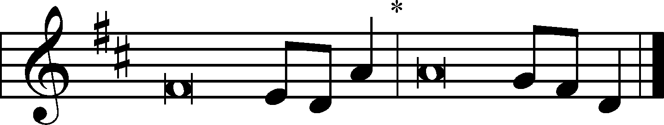
Introit Chanted Responsively) Psalm 66:1–2a, 17, 19–20; antiphon: Isaiah 48:20b
[With a voice of singing,] declare this with a shout of joy to the end of the earth. Alle- | luia.*
The Lord has redeemed his servant Jacob! Alle- | luia.
Shout for joy to God, | all the earth;*
sing the glory | of his name.
I cried to him | with my mouth,*
and high praise was | on my tongue.
But truly God has | listened;*
he has attended to the voice | of my prayer.
Blessèd | be God,*
because he has not rejected my prayer or removed his steadfast | love from me!
Glory be to the Father and | to the Son*
and to the Holy | Spirit;
as it was in the be- | ginning,*
is now, and will be forever. | Amen.
[With a voice of singing,] declare this with a shout of joy to the end of the earth. Alle- | luia.*
The Lord has redeemed his servant Jacob! Alle- | luia.

Kyrie LSB 186
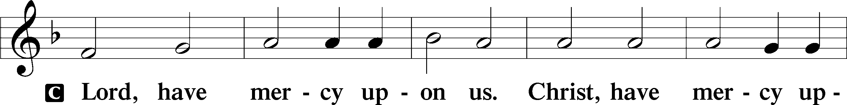
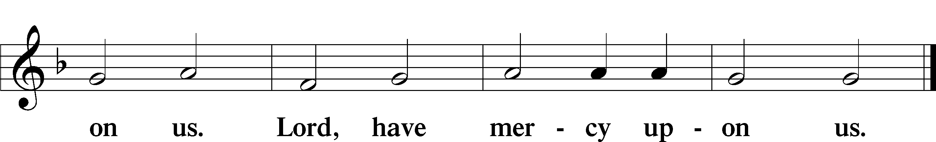

Gloria in Excelsis LSB 187
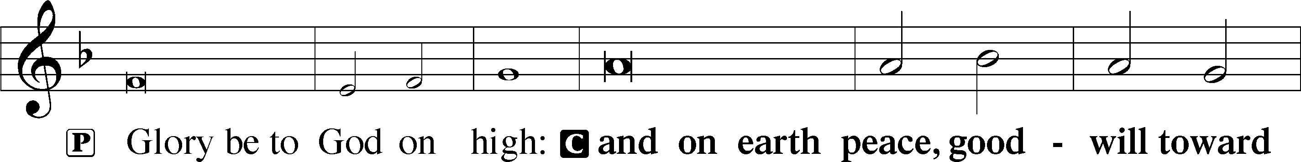
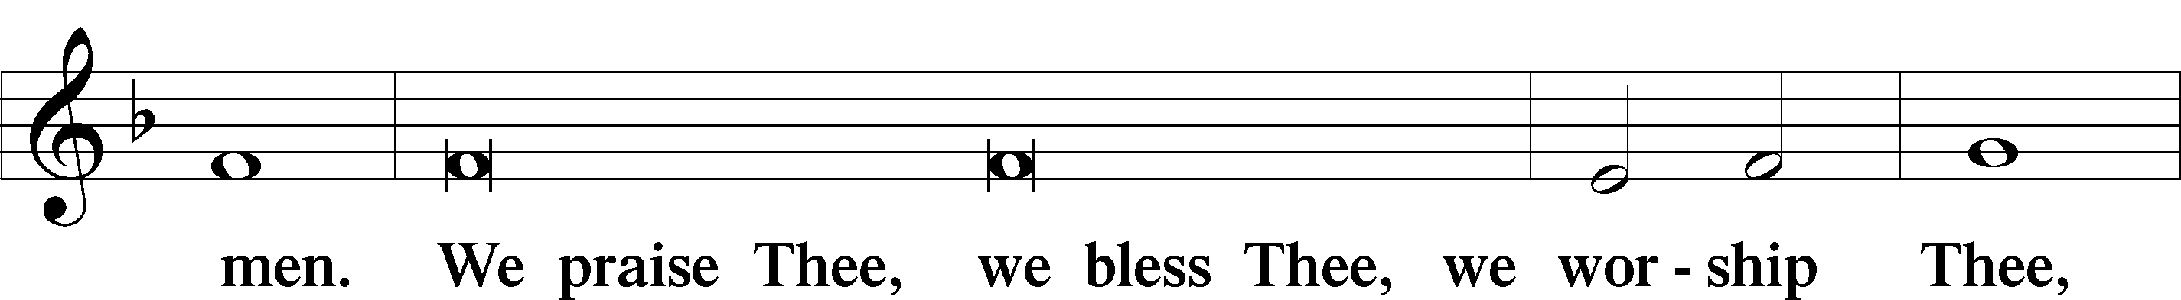
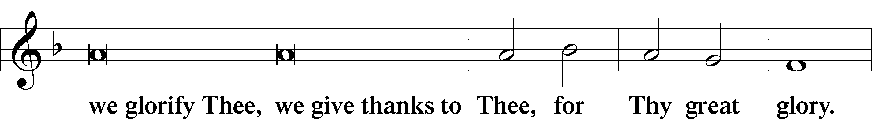
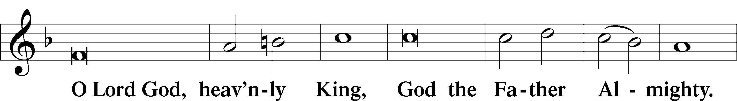
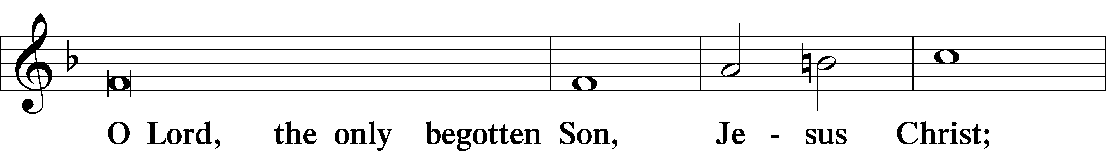
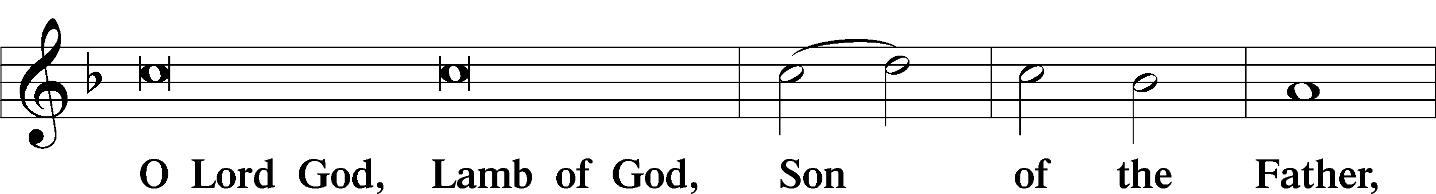
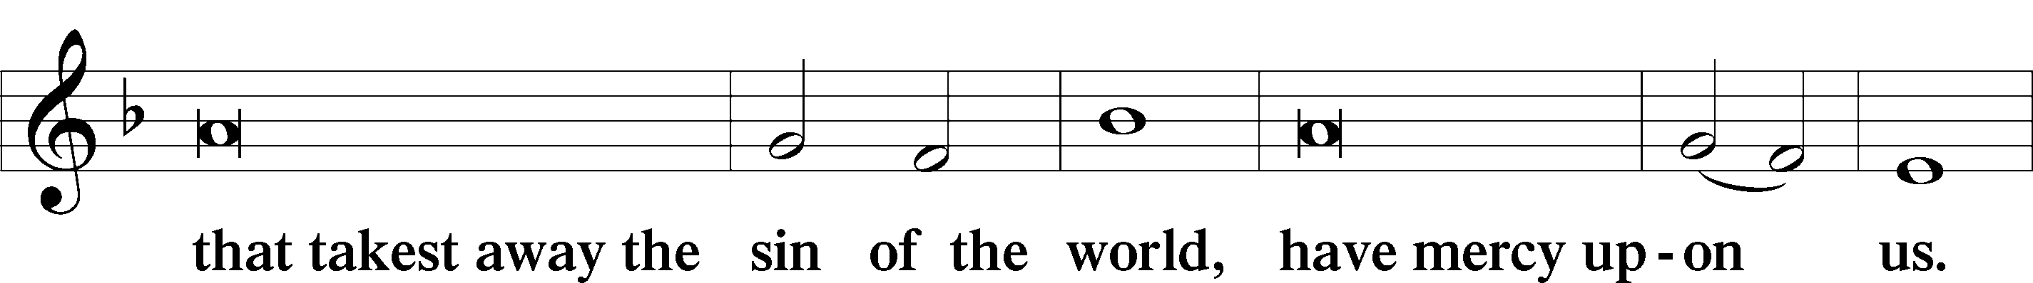
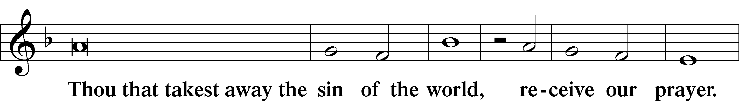
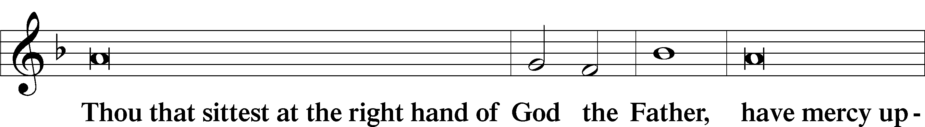
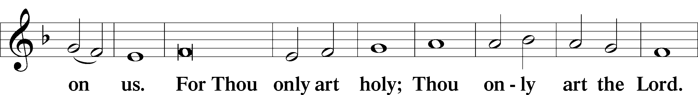
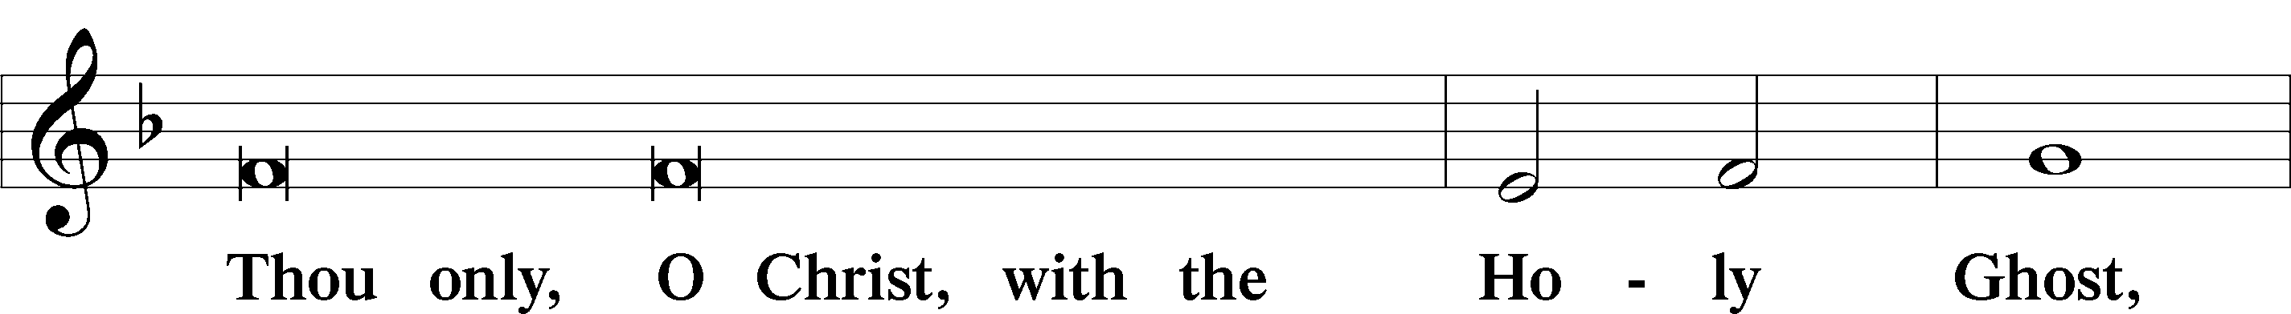
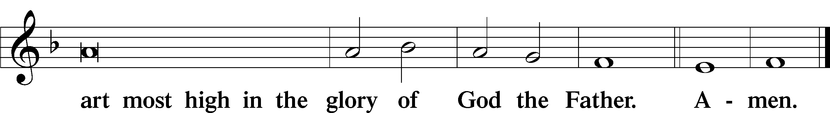

Salutation and Collect of the Day
P The Lord be with you.
C And with thy spirit.

P Let us pray. O God, the giver of all that is good, by Your holy inspiration grant that we may think those things that are right and by Your merciful guiding accomplish them; through Jesus Christ, Your Son, our Lord, who lives and reigns with You and the Holy Spirit, one God, now and forever. Amen. (sung)

Old Testament Reading Numbers 21:4–9
4From Mount Hor they set out by the way to the Red Sea, to go around the land of Edom. And the people became impatient on the way. 5And the people spoke against God and against Moses, “Why have you brought us up out of Egypt to die in the wilderness? For there is no food and no water, and we loathe this worthless food.” 6Then the Lord sent fiery serpents among the people, and they bit the people, so that many people of Israel died. 7And the people came to Moses and said, “We have sinned, for we have spoken against the Lord and against you. Pray to the Lord, that he take away the serpents from us.” So Moses prayed for the people. 8And the Lord said to Moses, “Make a fiery serpent and set it on a pole, and everyone who is bitten, when he sees it, shall live.” 9So Moses made a bronze serpent and set it on a pole. And if a serpent bit anyone, he would look at the bronze serpent and live.

A This is the Word of the Lord.
C Thanks be to God.

Verse: (Chanted Together) John 16:28
Alleluia. Christ, who has redeemed us | with his blood,*
is risen and has appeared unto us. Alle- | luia.
I came from the Father and have come in- | to the world,*
and now I am leaving the world and going to the Father. Alle- | luia.

Epistle James 1:22–27
22But be doers of the word, and not hearers only, deceiving yourselves. 23For if anyone is a hearer of the word and not a doer, he is like a man who looks intently at his natural face in a mirror. 24For he looks at himself and goes away and at once forgets what he was like. 25But the one who looks into the perfect law, the law of liberty, and perseveres, being no hearer who forgets but a doer who acts, he will be blessed in his doing.
26If anyone thinks he is religious and does not bridle his tongue but deceives his heart, this person’s religion is worthless. 27Religion that is pure and undefiled before God, the Father, is this: to visit orphans and widows in their affliction, and to keep oneself unstained from the world.

A This is the Word of the Lord.
C Thanks be to God.

Alleluia LSB 190
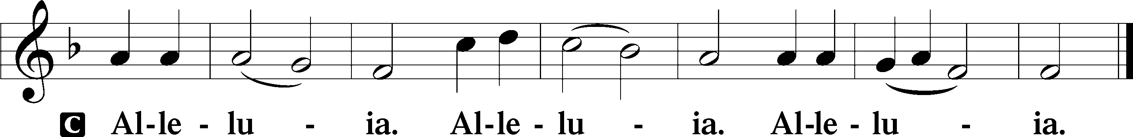

Holy Gospel John 16:23–33
P The Holy Gospel according to St. John, the sixteenth chapter.
C Glory be to Thee, O Lord.

23[Jesus said:] “In that day you will ask nothing of me. Truly, truly, I say to you, whatever you ask of the Father in my name, he will give it to you. 24Until now you have asked nothing in my name. Ask, and you will receive, that your joy may be full.
25“I have said these things to you in figures of speech. The hour is coming when I will no longer speak to you in figures of speech but will tell you plainly about the Father. 26In that day you will ask in my name, and I do not say to you that I will ask the Father on your behalf; 27for the Father himself loves you, because you have loved me and have believed that I came from God. 28I came from the Father and have come into the world, and now I am leaving the world and going to the Father.”
29His disciples said, “Ah, now you are speaking plainly and not using figurative speech! 30Now we know that you know all things and do not need anyone to question you; this is why we believe that you came from God.” 31Jesus answered them, “Do you now believe? 32Behold, the hour is coming, indeed it has come, when you will be scattered, each to his own home, and will leave me alone. Yet I am not alone, for the Father is with me. 33I have said these things to you, that in me you may have peace. In the world you will have tribulation. But take heart; I have overcome the world.”

P This is the Gospel of the Lord.
C Praise be to Thee, O Christ.

Apostles’ Creed
C I believe in God, the Father Almighty,
maker of heaven and earth.

And in Jesus Christ, His only Son, our Lord,
who was conceived by the Holy Spirit,
born of the virgin Mary,
suffered under Pontius Pilate,
was crucified, died and was buried.
He descended into hell.
The third day He rose again from the dead.
He ascended into heaven
and sits at the right hand of God the Father Almighty.
From thence He will come to judge the living and the dead.

I believe in the Holy Spirit,
the holy Christian Church,
the communion of saints,
the forgiveness of sins,
the resurrection of the body,
and the life T everlasting. Amen.

Hymn of the Day: “Our Father, Who from Heaven Above” LSB 766
Men – stanzas 3 & 5 Women – stanzas 4 & 6
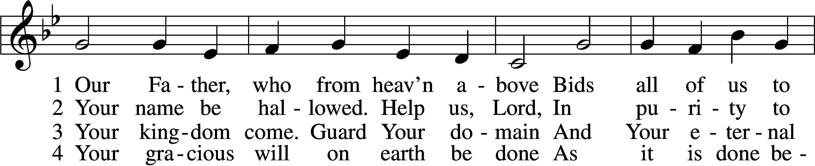
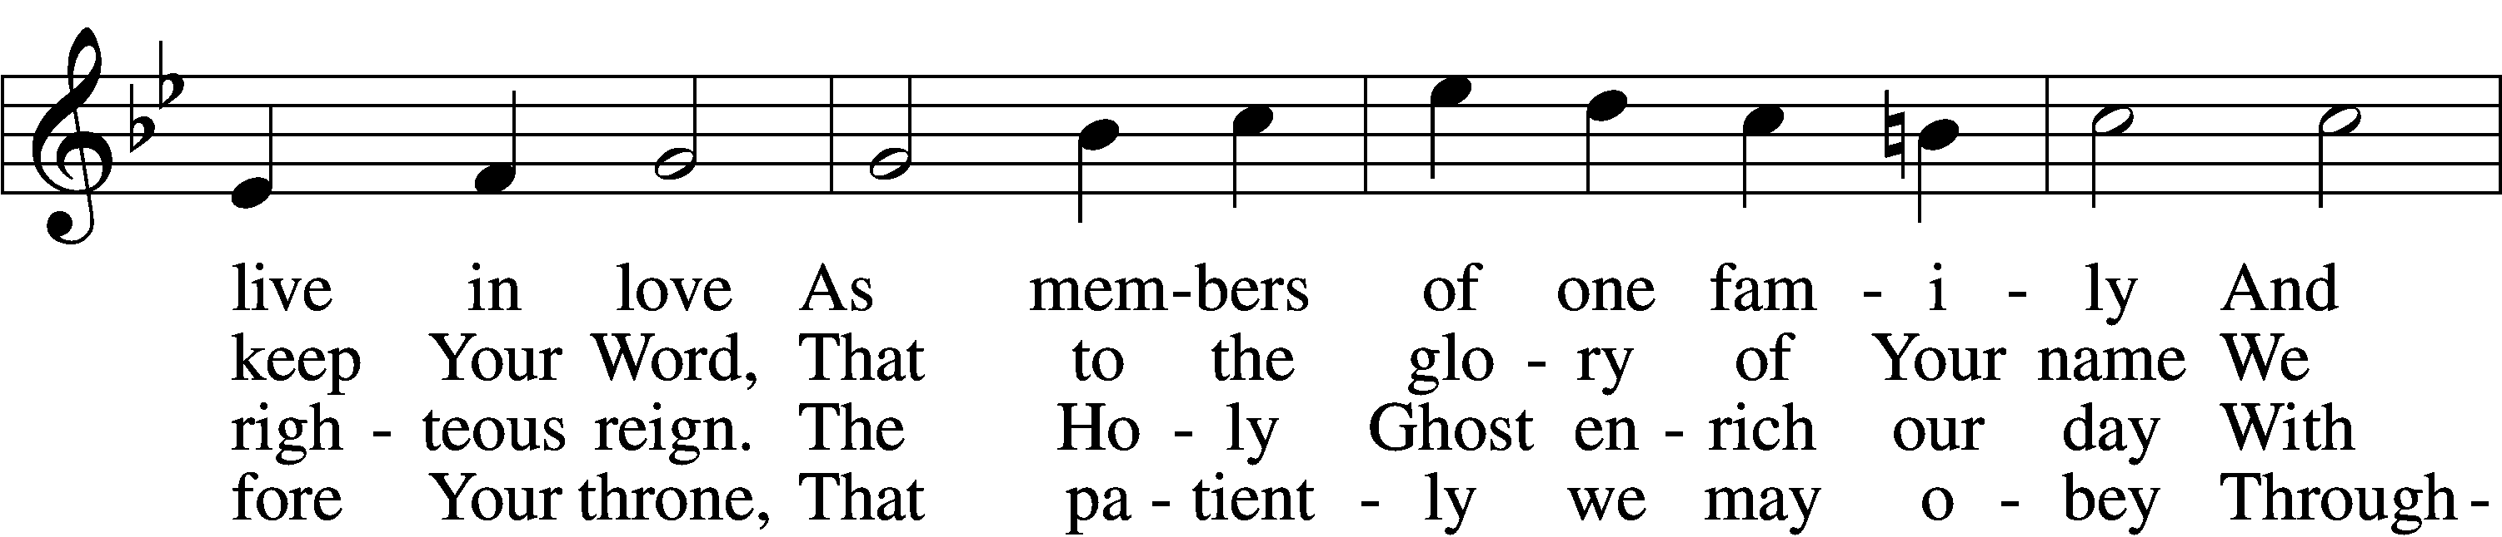
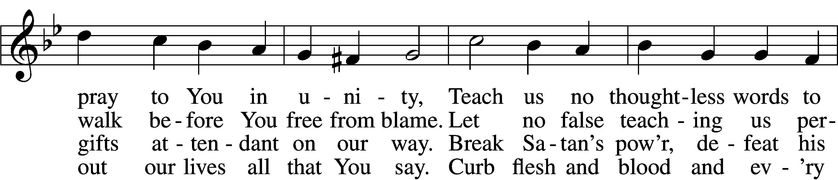
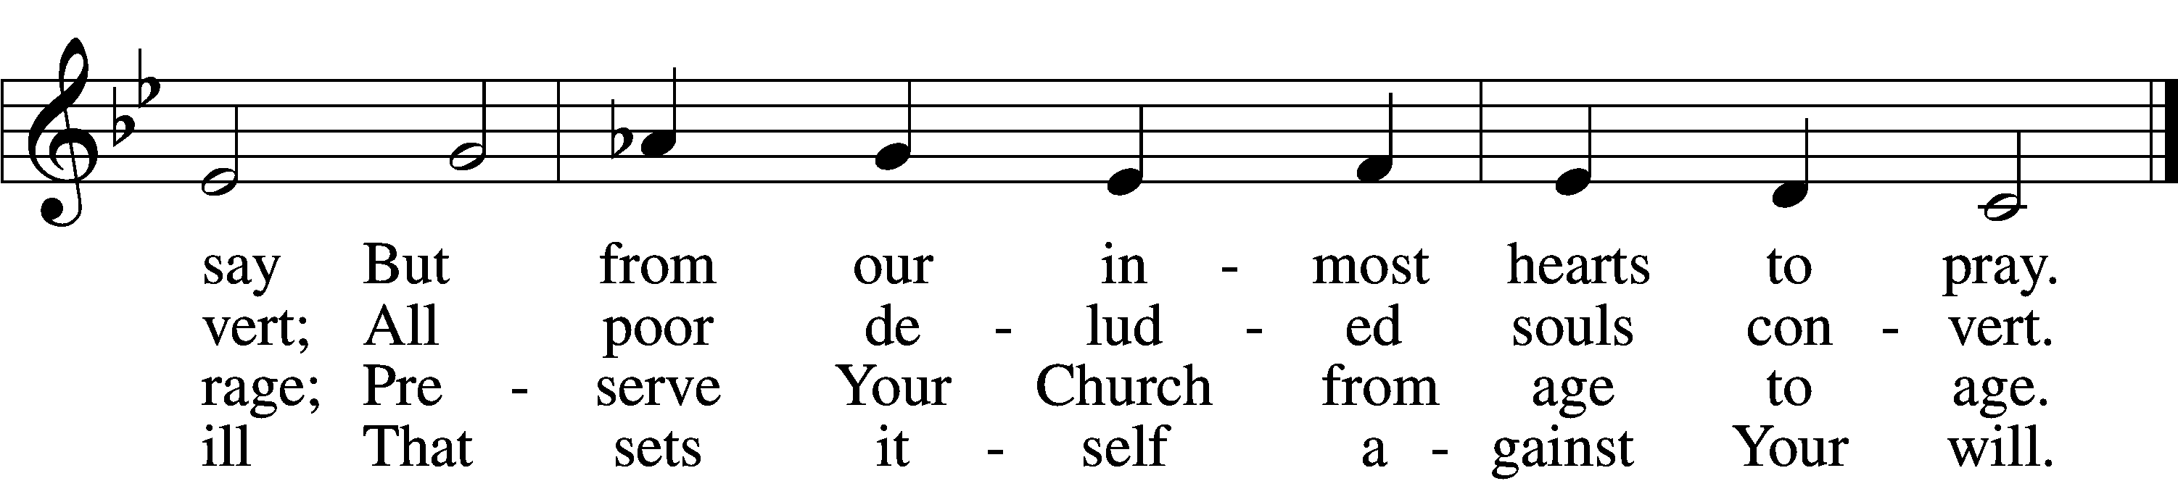

5. Give us this day our daily bread,
And let us all be clothed and fed.
Save us from hardship, war, and strife;
In plague and famine, spare our life,
That we in honest peace may live,
To care and greed no entrance give.

6. Forgive our sins, Lord, we implore,
That they may trouble us no more;
We, too, will gladly those forgive
Who hurt us by the way they live.
Help us in our community
To serve each other willingly.

7. Lead not into temptation, Lord,
Where our grim foe and all his horde
Would vex our souls on ev’ry hand.
Help us resist, help us to stand
Firm in the faith, a mighty host,
Through comfort of the Holy Ghost.

8. From evil, Lord, deliver us;
The times and days are perilous.
Redeem us from eternal death,
And, when we yield our dying breath,
Console us, grant us calm release,
And take our souls to You in peace.

9. Amen, that is, so shall it be.
Make strong our faith in You, that we
May doubt not but with trust believe
That what we ask we shall receive.
Thus in Your name and at Your Word
We say, “Amen, O hear us, Lord!”

Text: Martin Luther, 1483–1546; (sts. 1, 6, 8–9): tr. The Lutheran Hymnal, 1941, alt.; (sts. 2–5, 7): tr. F. Samuel Janzow, 1913–2001, alt.
Tune: attr. Martin Luther, 1483–1546
Text (sts. 1, 6, 8–9): Public domain
Text (sts. 2–5, 7): © 1980 Concordia Publishing House. Used by permission: LSB Hymn License no. 110002144
Tune: Public domain

Sermon

Offertory: “He Is Arisen! Glorious Word” LSB 488
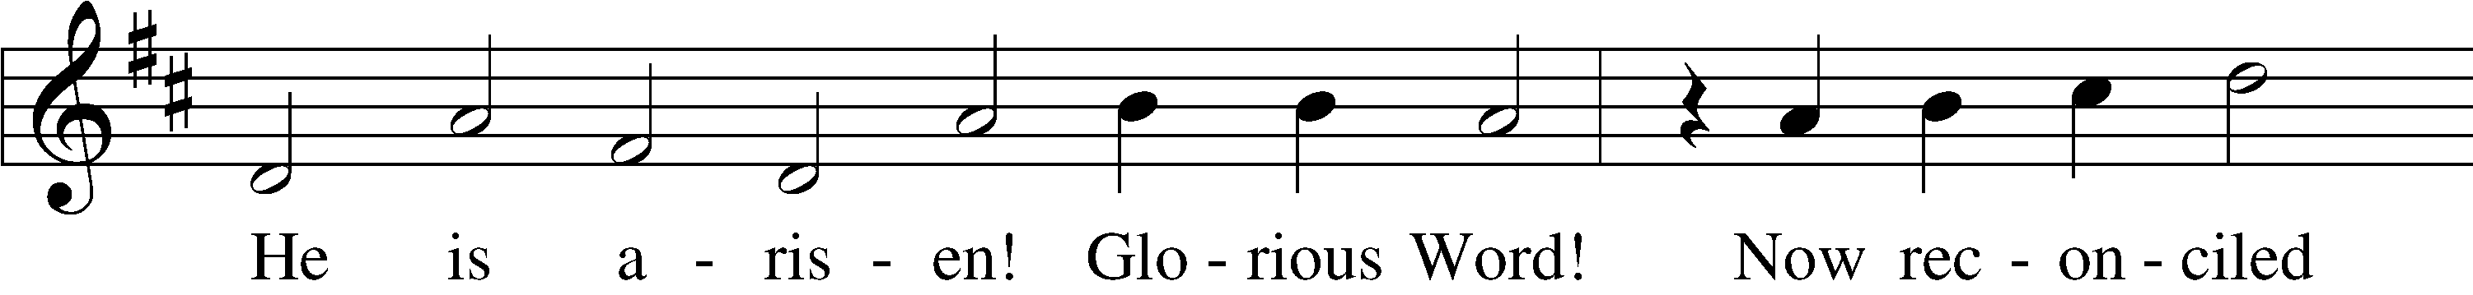
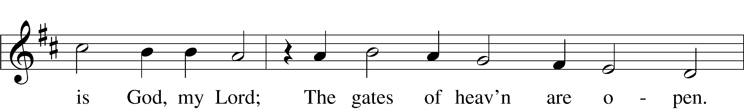
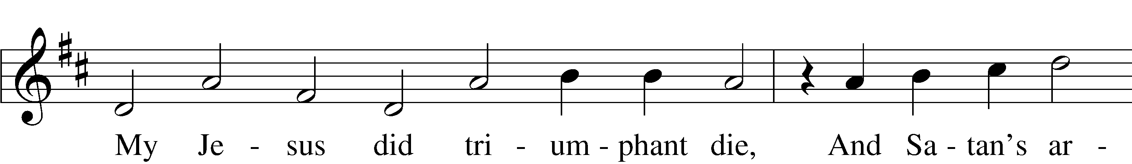
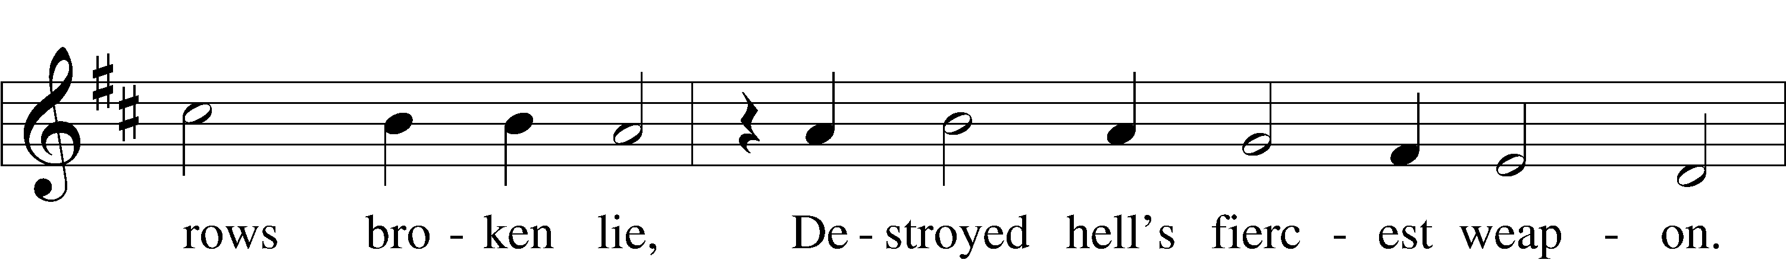
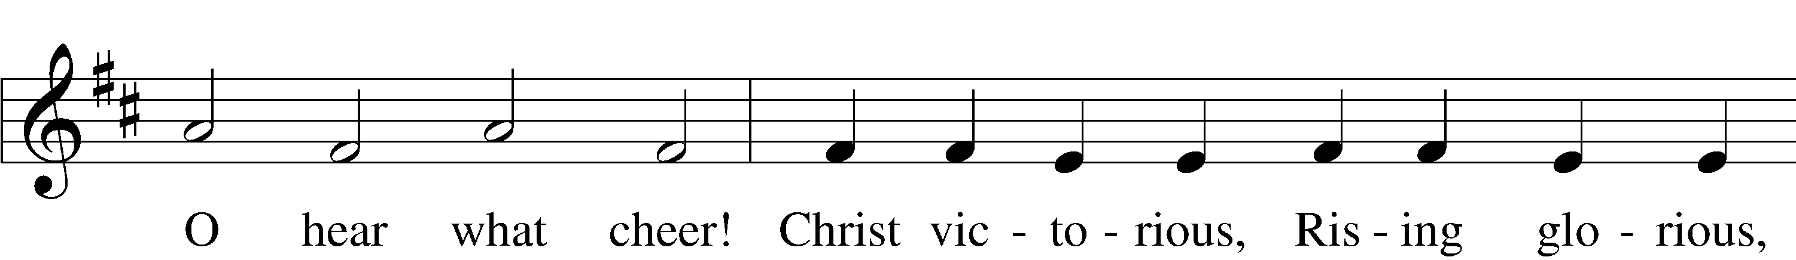
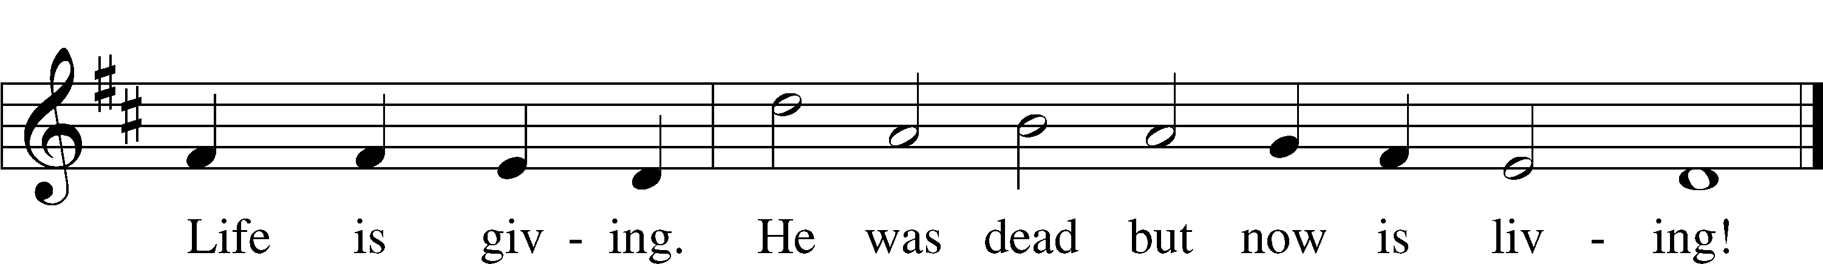
Text: Birgitte Katerine Boye, 1742–1824; tr. George A. T. Rygh, 1860–1942, alt.
Tune: Philipp Nicolai, 1556–1608
Text and tune: Public domain

Offering

Prayer of the Church

Service of the Sacrament

Preface LSB 194
P The Lord be with you.
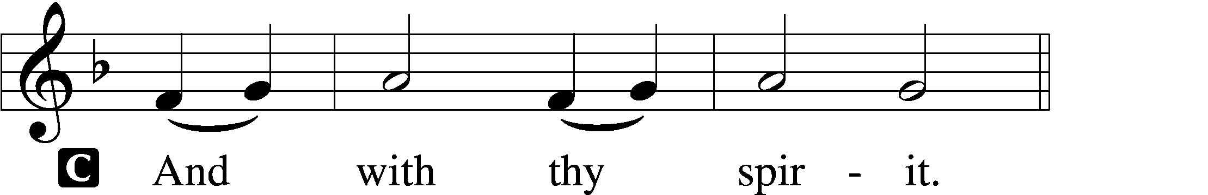

P Lift up your hearts.
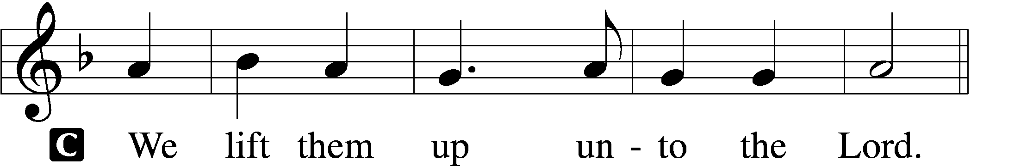

P Let us give thanks unto the Lord, our God.
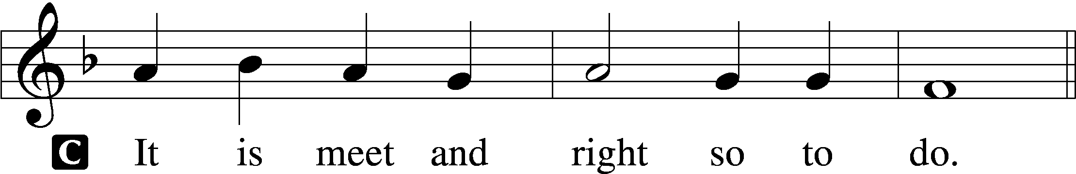

P It is truly meet, right, and salutary that we should at all times and in all places give thanks to You, holy Lord, almighty Father, everlasting God. And most especially are we bound to praise You on this day for the glorious resurrection of Your Son, Jesus Christ, the very Paschal Lamb, who was sacrificed for us and bore the sins of the world. By His dying He has destroyed death, and by His rising again He has restored to us everlasting life. Therefore with Mary Magdalene, Peter and John, and with all the witnesses of the resurrection, with angels and archangels, and with all the company of heaven we laud and magnify Your glorious name, evermore praising You and saying:

Sanctus LSB 195
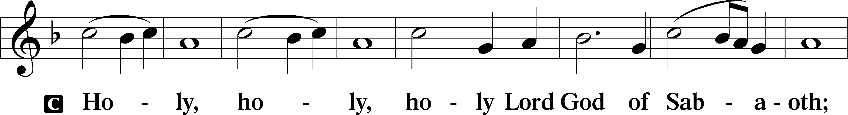
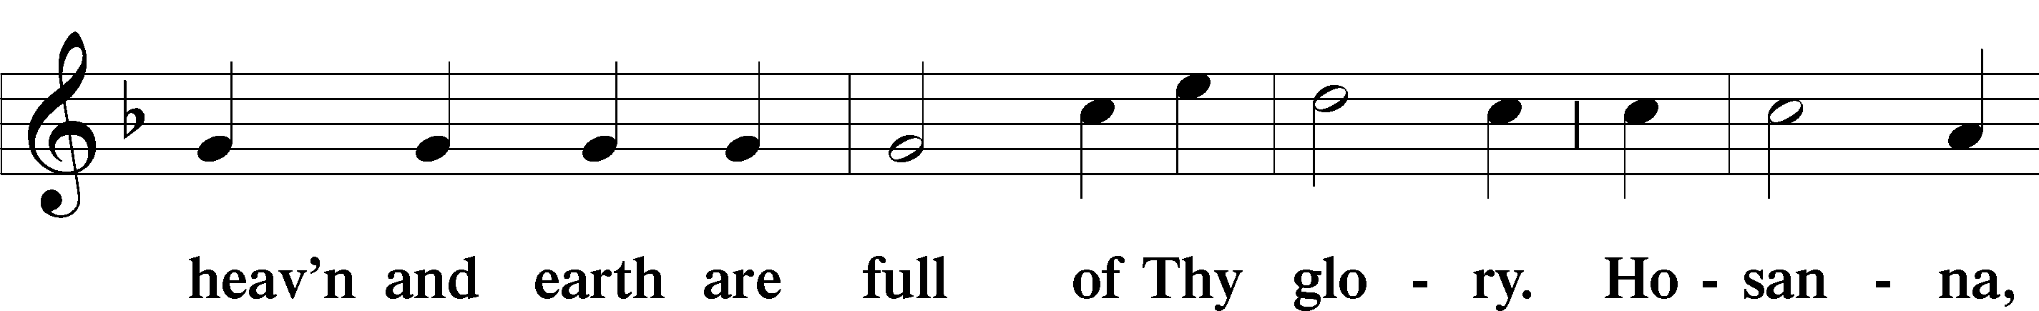
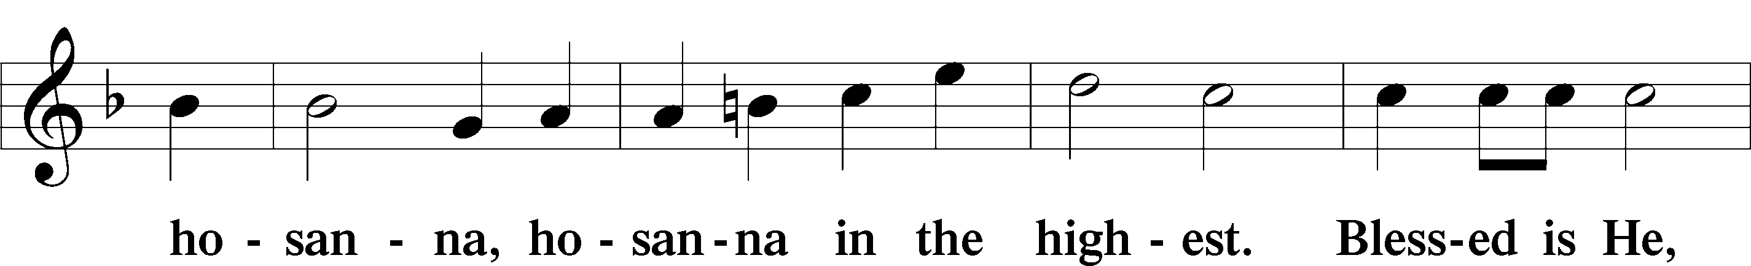
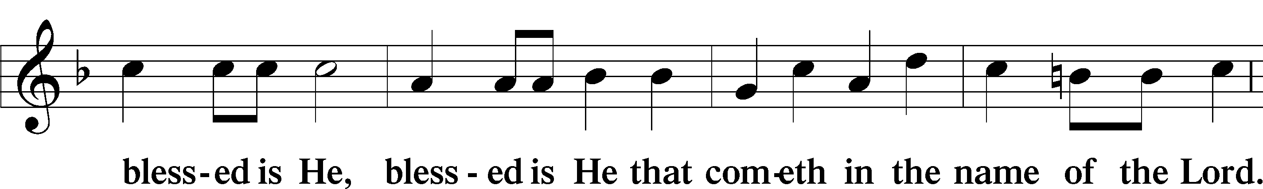
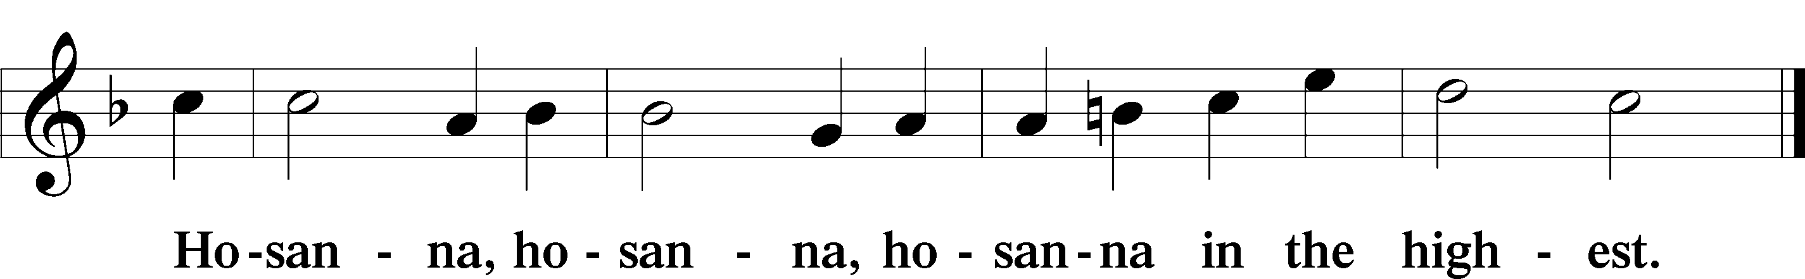

Lord’s Prayer LSB 196
Our Father who art in heaven,
hallowed be Thy name,
Thy kingdom come,
Thy will be done on earth as it is in heaven;
give us this day our daily bread;
and forgive us our trespasses as we forgive those who trespass against us;
and lead us not into temptation,
but deliver us from evil.
For Thine is the kingdom and the power and the glory forever and ever. Amen.

The Words of Our Lord LSB 197
P Our Lord Jesus Christ, on the night when He was betrayed, took bread, and when He had given thanks, He broke it and gave it to the disciples and said: “Take, eat; this is My T body, which is given for you. This do in remembrance of Me.”

In the same way also He took the cup after supper, and when He had given thanks, He gave it to them, saying: “Drink of it, all of you; this cup is the new testament in My T blood, which is shed for you for the forgiveness of sins. This do, as often as you drink it, in remembrance of Me.”

Pax Domini LSB 197
P The peace of the Lord be with you always.

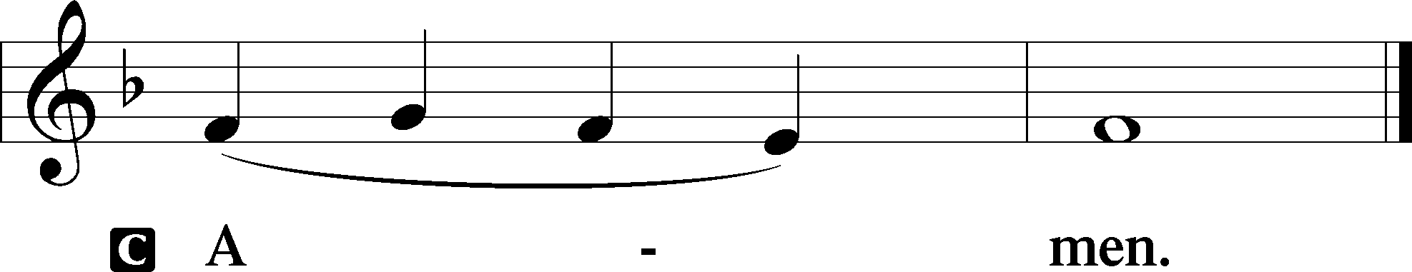

Agnus Dei LSB 198
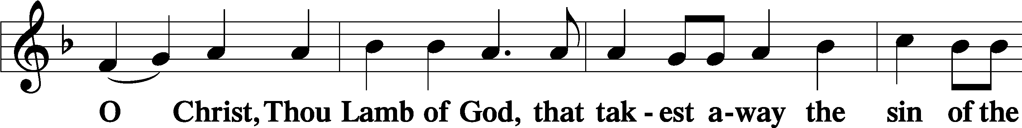
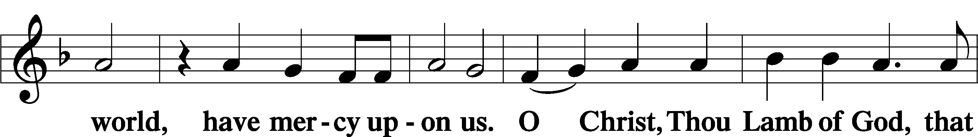
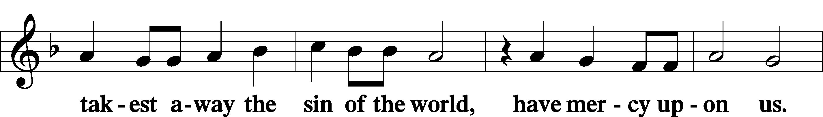
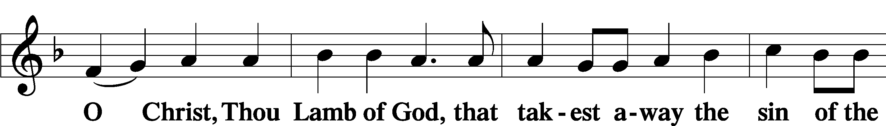
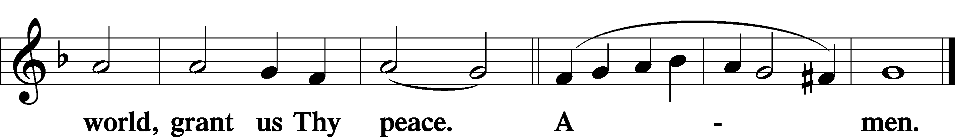

Distribution Hymn: “Christ the Lord Is Risen Today” LSB 469
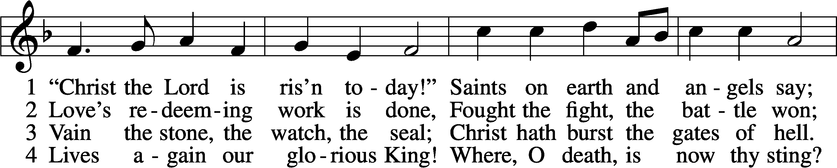
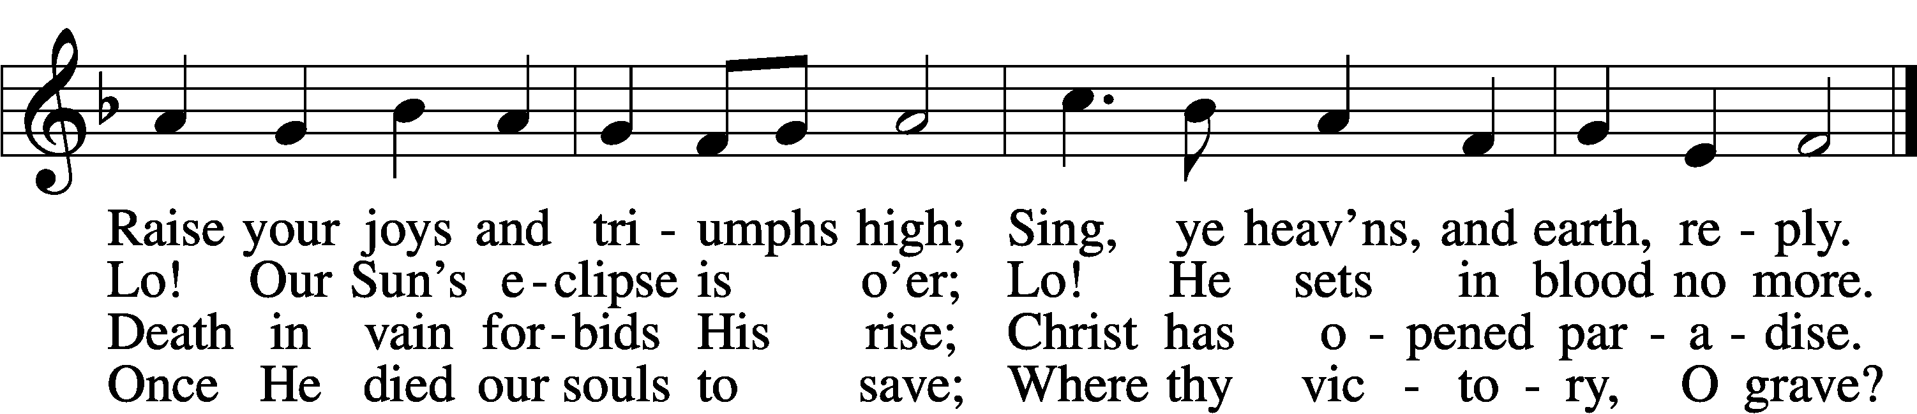

5. Soar we now where Christ has led;
Foll’wing our exalted Head.
Made like Him, like Him we rise;
Ours the cross, the grave, the skies.

6. Hail the Lord of earth and heav’n!
Praise to Thee by both be giv’n!
Thee we greet triumphant now:
Hail, the resurrection, Thou!

Text: Charles Wesley, 1707–88, alt.
Tune: French, 13th cent.
Text and tune: Public domain

Distribution Hymn: “Soul, Adorn Yourself with Gladness” LSB 636
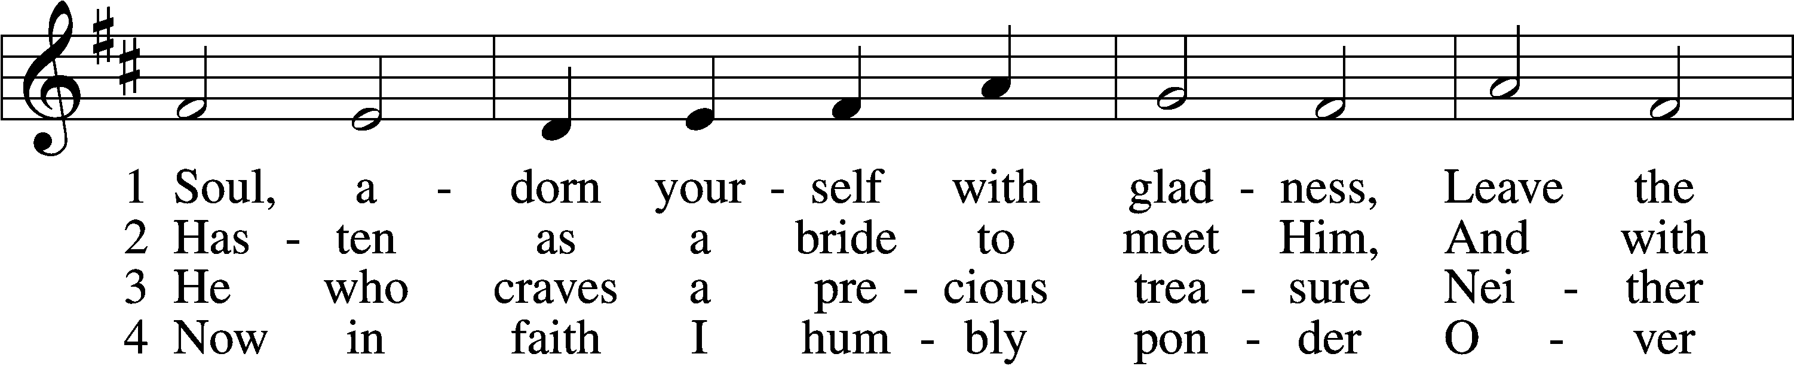
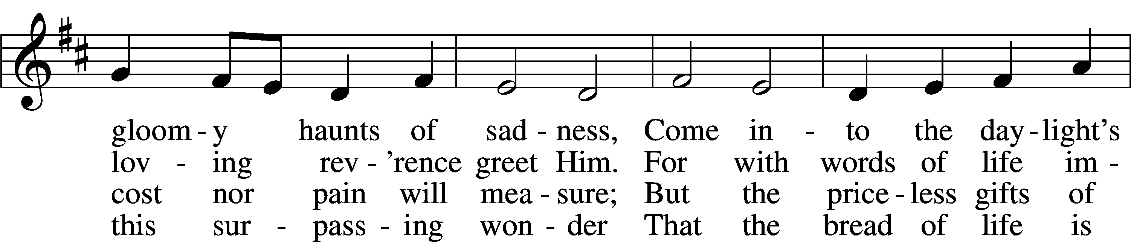
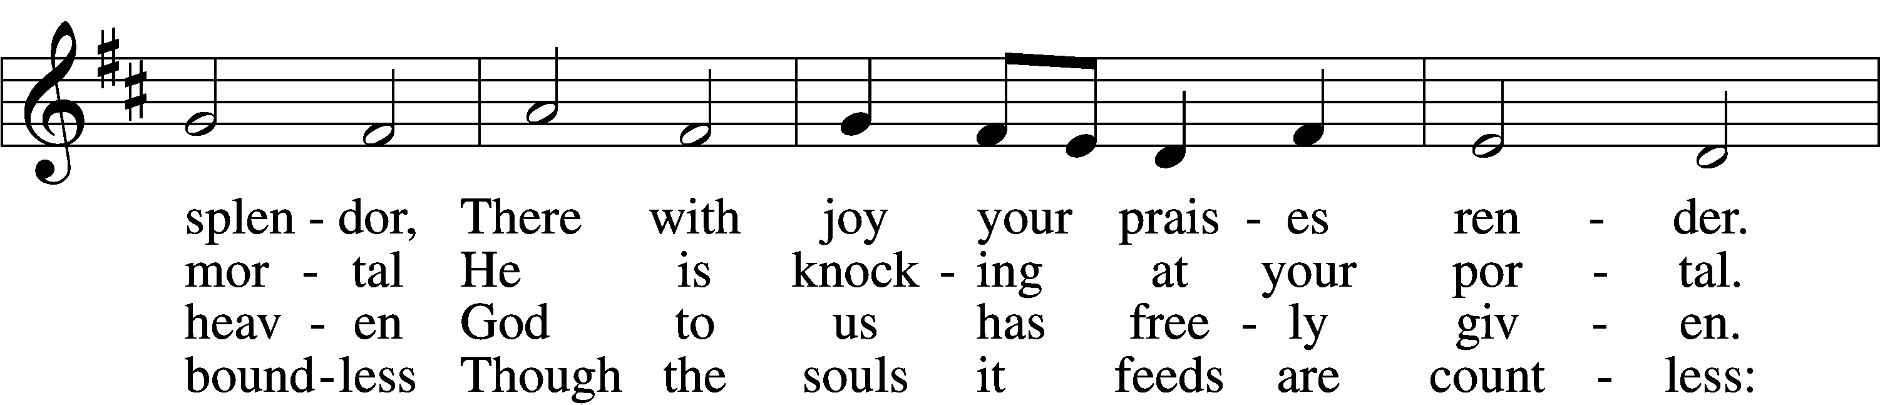
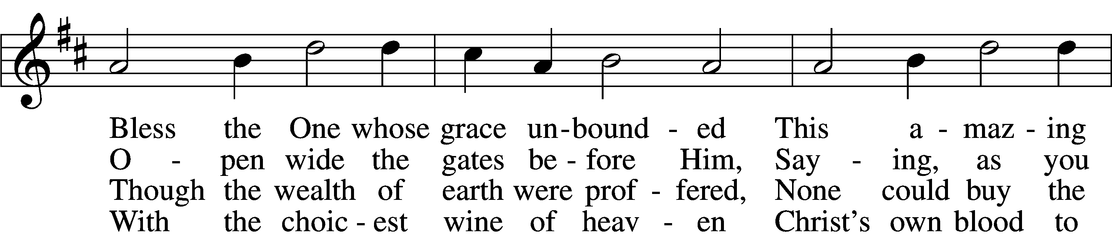
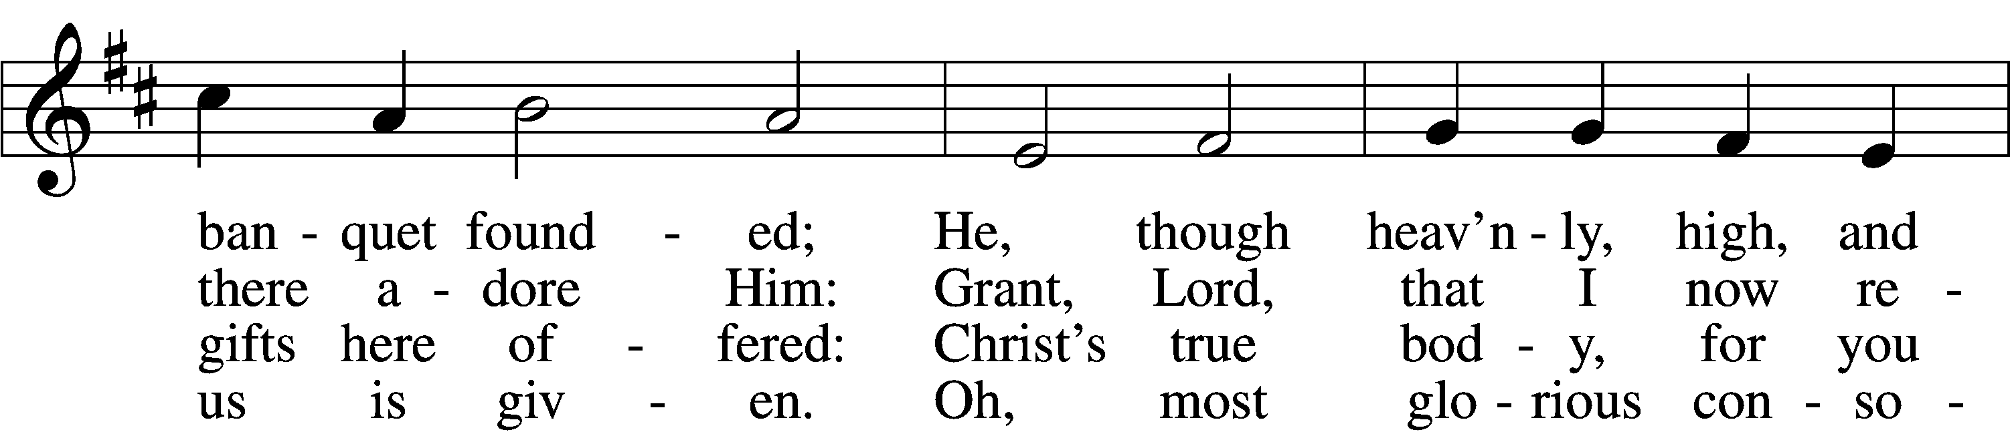
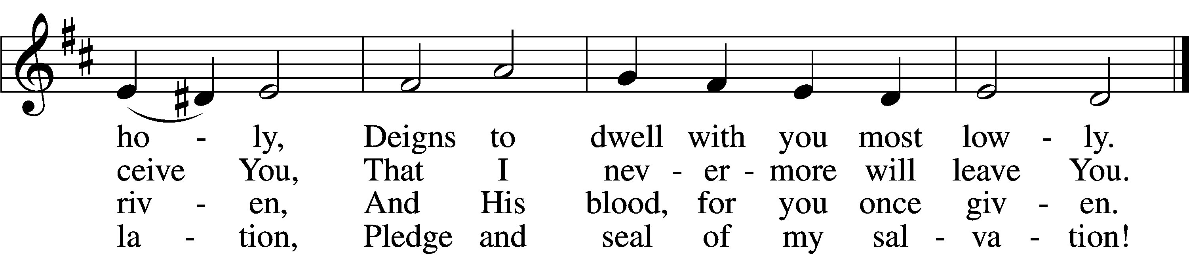

5. Jesus, source of lasting pleasure,
Truest friend, and dearest treasure,
Peace beyond all understanding,
Joy into all life expanding:
Humbly now, I bow before You;
Love incarnate, I adore You;
Worthily let me receive You
And, so favored, never leave You.

6. Jesus, sun of life, my splendor,
Jesus, friend of friends, most tender,
Jesus, joy of my desiring,
Fount of life, my soul inspiring:
At Your feet I cry, my maker,
Let me be a fit partaker
Of this blessèd food from heaven,
For our good, Your glory, given.
7. Lord, by love and mercy driven,
You once left Your throne in heaven
On the cross for me to languish
And to die in bitter anguish,
To forego all joy and gladness
And to shed Your blood in sadness.
By this blood redeemed and living,
Lord, I praise You with thanksgiving.

8. Jesus, bread of life, I pray You,
Let me gladly here obey You.
By Your love I am invited,
Be Your love with love requited;
By this Supper let me measure,
Lord, how vast and deep love’s treasure.
Through the gift of grace You give me
As Your guest in heav’n receive me.

Text: Johann Franck, 1618–77; (sts. 1, 4–5): tr. Lutheran Book of Worship, 1978; (sts. 2–3, 6–8): tr. Catherine Winkworth, 1827–78, alt.
Tune: Johann Crüger, 1598–1662
Text (sts. 1, 4–5): © 1978 Lutheran Book of Worship. Used by permission: LSB Hymn License no. 110002144
Text (sts. 2–3, 6–8) and tune: Public domain

Nunc Dimittis LSB 199
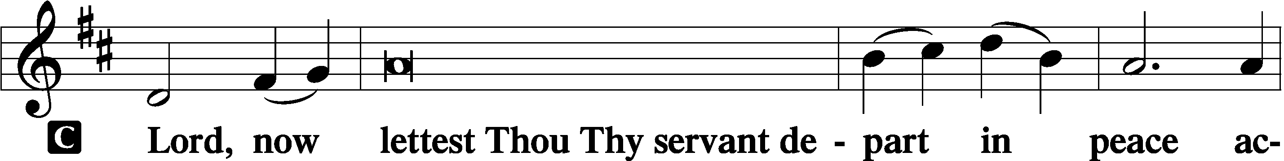

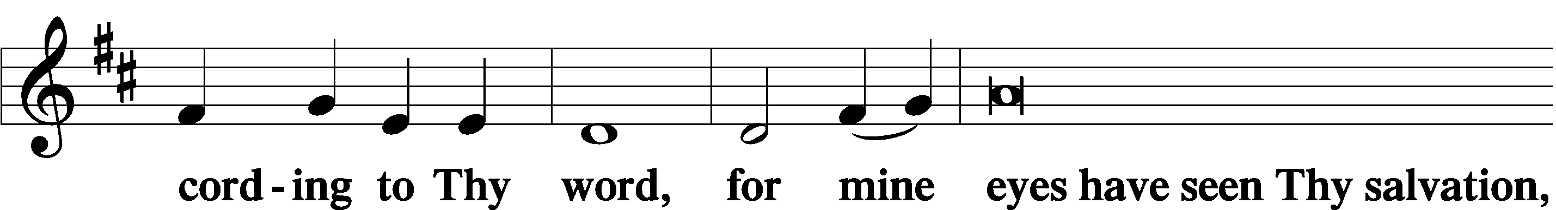

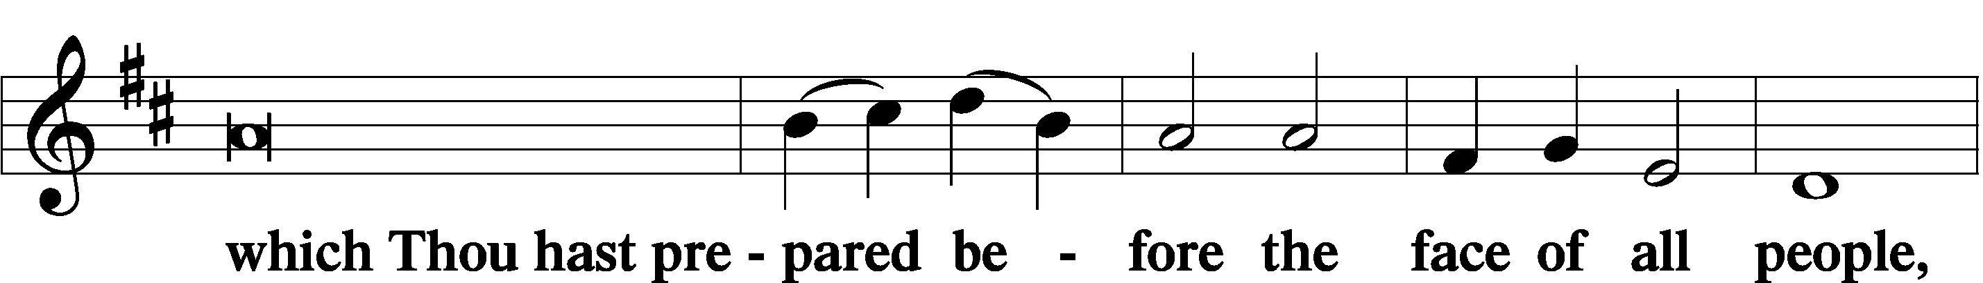

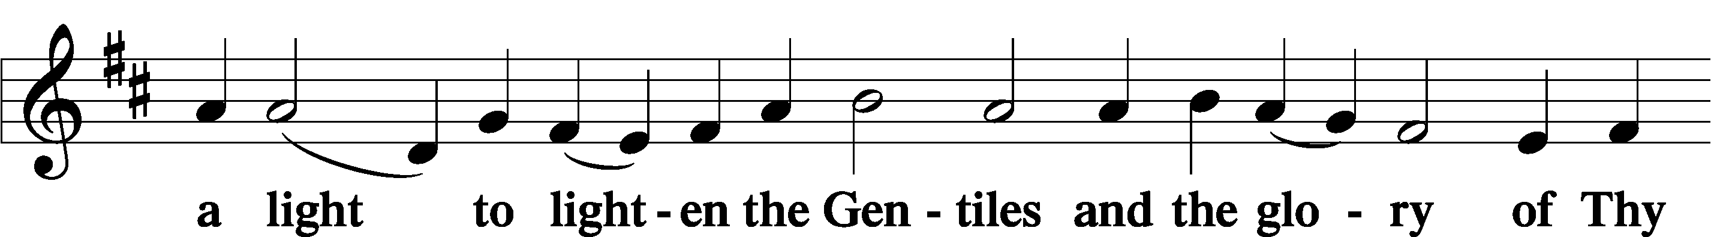

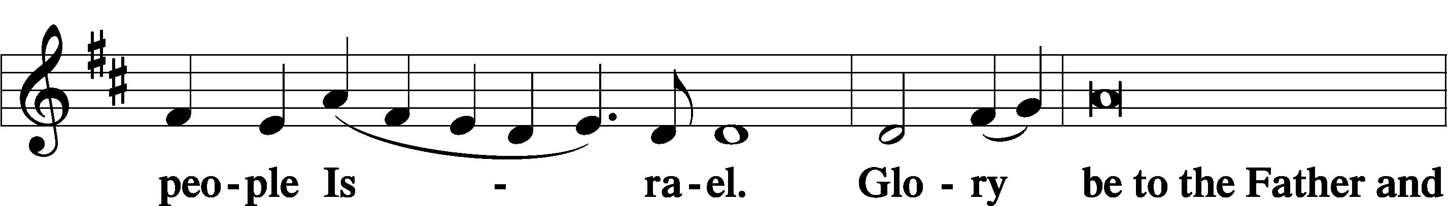

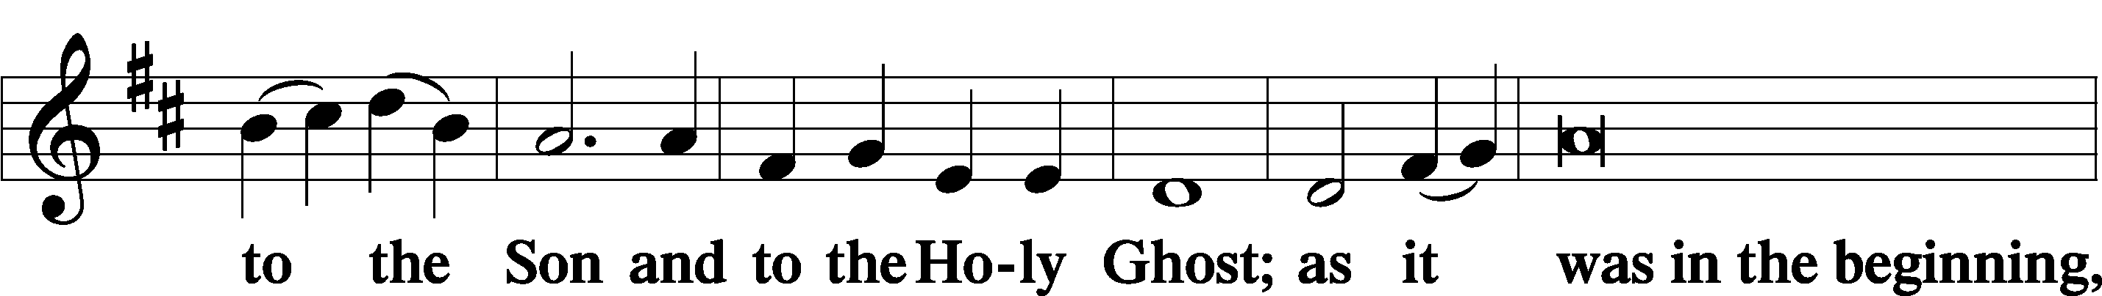

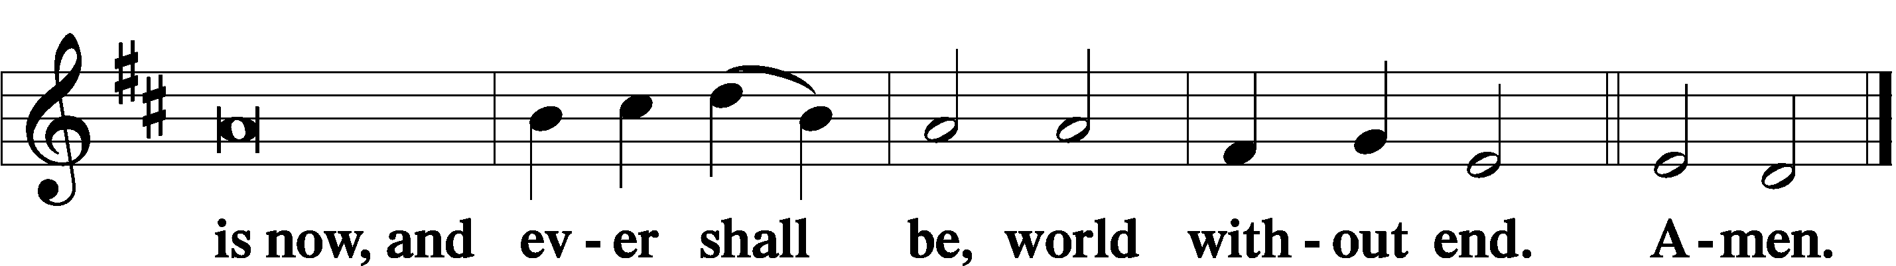

Thanksgiving LSB 200
A O give thanks unto the Lord, for He is good,

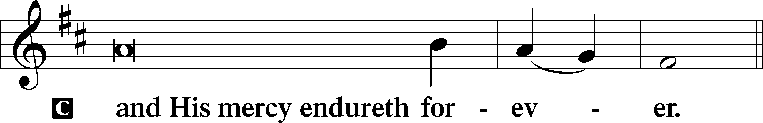

Post-Communion Collect
A Let us pray.
We give thanks to You, almighty God, that You have refreshed us through this salutary gift, and we implore You that of Your mercy You would strengthen us through the same in faith toward You and in fervent love toward one another; through Jesus Christ, Your Son, our Lord, who lives and reigns with You and the Holy Spirit, one God, now and forever.

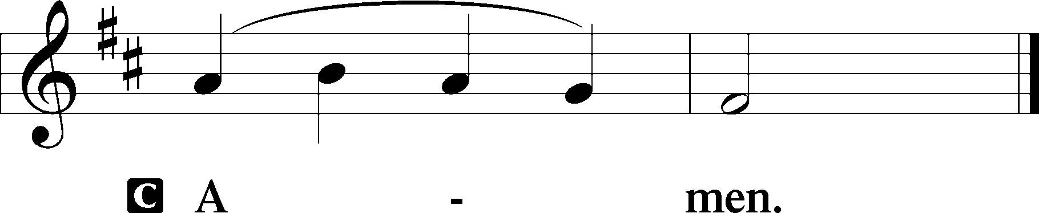

Salutation LSB 201
P The Lord be with you.

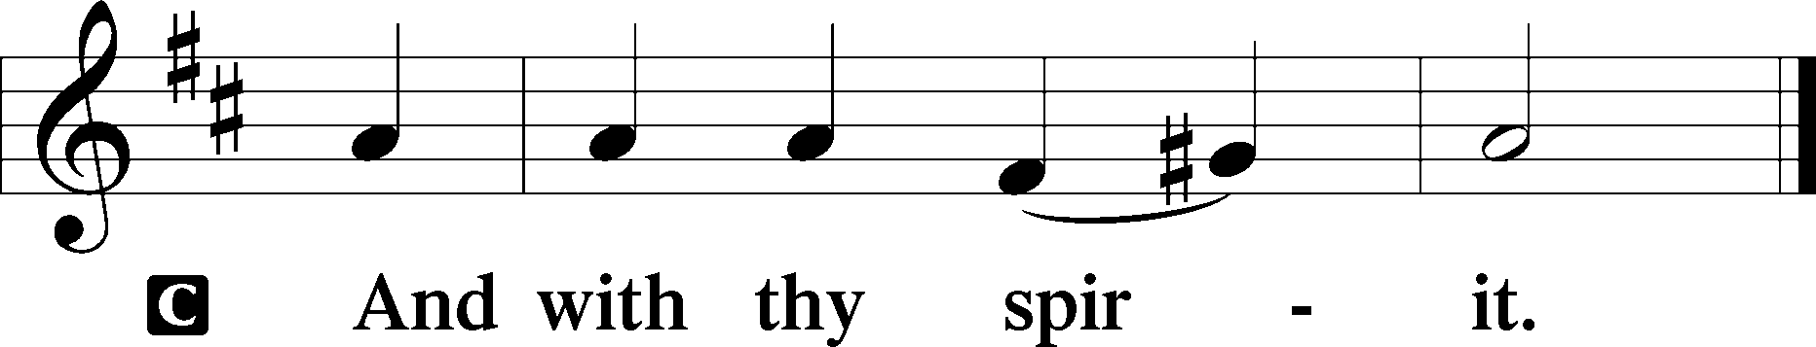

Benedicamus LSB 202
A Bless we the Lord.

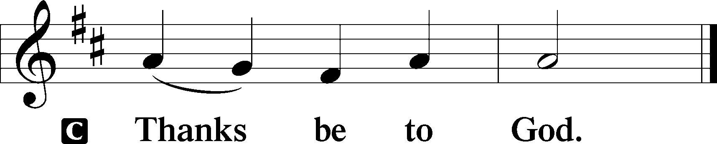

Benediction LSB 202
P The Lord bless you and keep you.
The Lord make His face shine upon you and be gracious unto you.
The Lord lift up His countenance upon you and T give you peace.
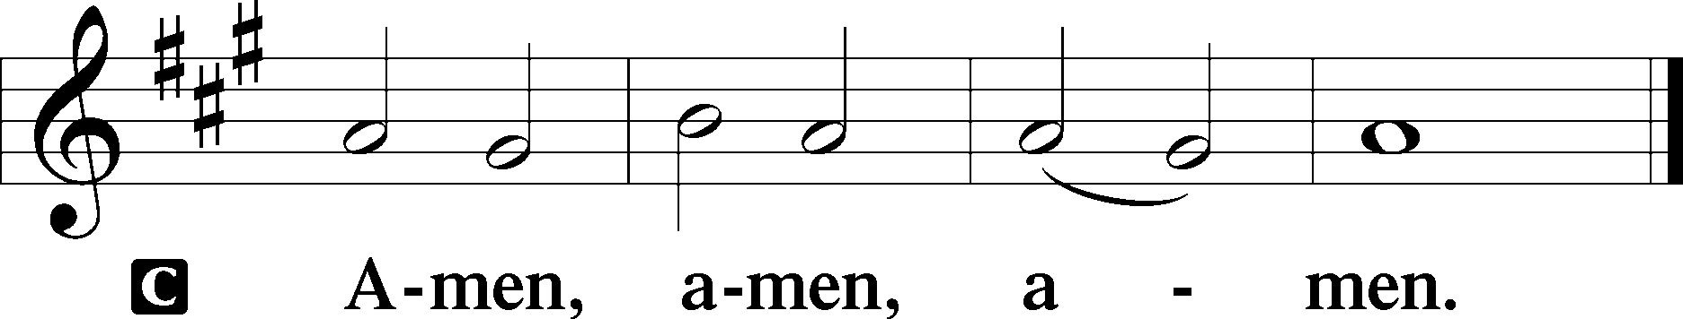

Hymn to Depart: “Hear Us, Father, When We Pray” LSB 773
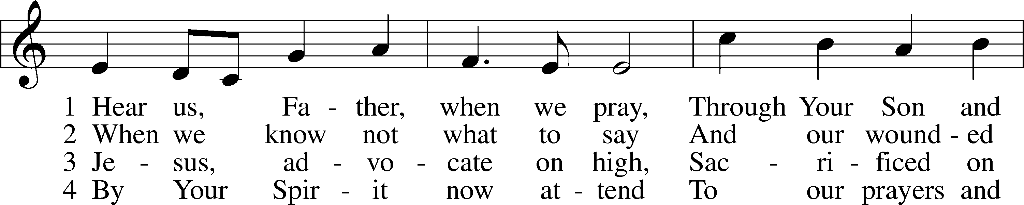
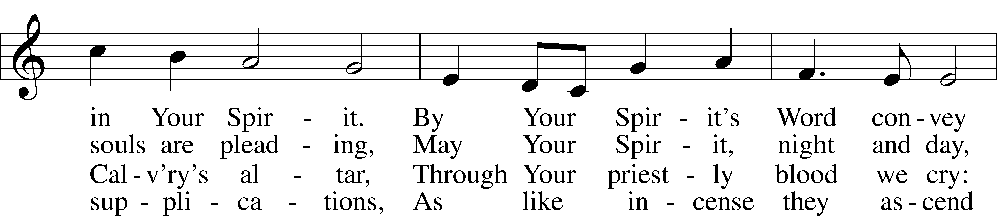
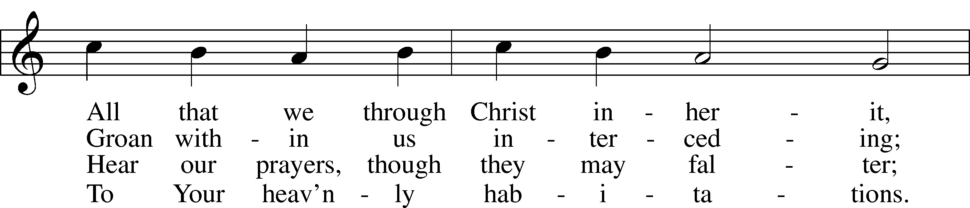
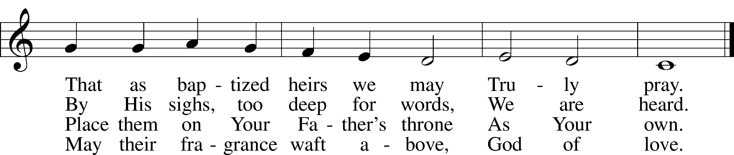
Text: Chad L. Bird, 1970
Tune: Geist-reiches Gesang-Buch, 1704, Halle, ed. Johann A. Freylinghausen
Text: © Chad L. Bird. Used by permission: LSB Hymn License no. 110002144
Tune: Public domain

Acknowledgments
Unless otherwise indicated, Scripture quotations are from the ESV® Bible (The Holy Bible, English Standard Version®), copyright © 2001 by Crossway, a publishing ministry of Good News Publishers. Used by permission. All rights reserved.
Created by Lutheran Service Builder © 2024 Concordia Publishing House.

